DEPARTMENT OF CIVIL ENGINEERING

B.Tech.

4th SEMESTER

Fluid Flow in Pipes and Channels

Chapter 2

Flow through Pipes

Teacher Concerned

R. R. Mir

Turbulent Flow in Pipes

Introduction to Turbulent Flow:

There are two types of flow-namely laminar flow and turbulent flow. We know in laminar flow, the fluid particles have an orderly motion along stream lines. As the rate of flow is increased a stage is reached in which the fluid particles which had an orderly motion are subjected to random collisions resulting in eddies spreading in the whole region of flow. This state of instability in the fluid motion is produced due to the varied velocities of adjacent fluid layers and the viscous force or resistance between them.
Rough projections of the boundary surface and sudden or sharp discontinuities in the geometry of the boundary surfaces also produce eddy currents and disturbances. At low velocities such discontinuities get damped by the stabilizing viscous resistance.
As the velocity exceeds a limit these disturbances do not get damped and spread to the whole flow region, except for a very thin layer adjoining the boundary. The fluid particles moving in random directions are subjected to repeated impact. Such a condition is called Turbulence.
A loss of energy occurs due to turbulence. It was possible in a viscous flow to obtain a relation between shearing stress, the dynamic viscosity of the fluid and the velocity gradient. No such relation can be mathematically obtained in turbulent flow. We can however analyse turbulent flow on the basis of a few empirical theories.
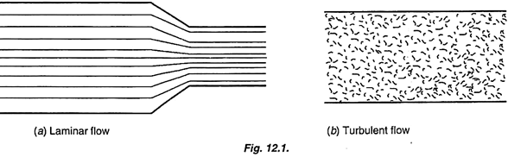

The Darcy Weisbach Equation:
Consider a liquid flowing through a pipe of diameter D. Consider sections 1-1 and 2-2 I units apart. Let dz be the difference in levels between the two sections. Let v be the mean velocity flow. Let A be the sectional area of flow. Let p₁ and p₂ be the pressure intensities at the sections 1-1 and 2-2. Consider the fluid body between the two sections. Since the fluid body has no acceleration the resultant force in the direction of motion should be equal to zero.

The forces acting along the line of motion are the following:
(i) Pressure force = (p₁ – p₂) A
(ii) Component of the weight of the liquid = wAL sin θ
(iii) Shear or frictional resistance
= Shear stress x wetted surface area = τ₀ PL
where P = Wetted perimeter.
Since the resultant of the above forces is zero
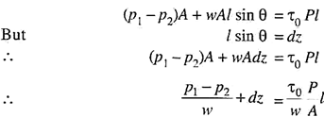
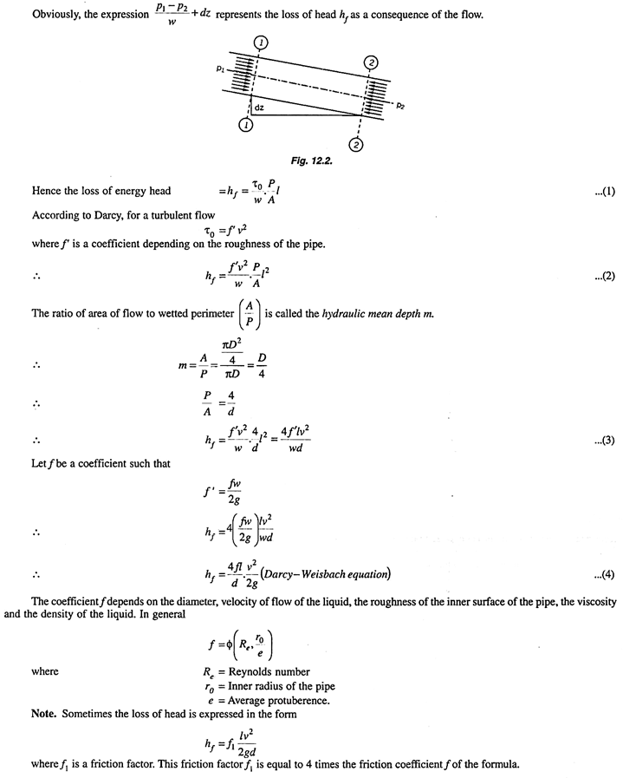
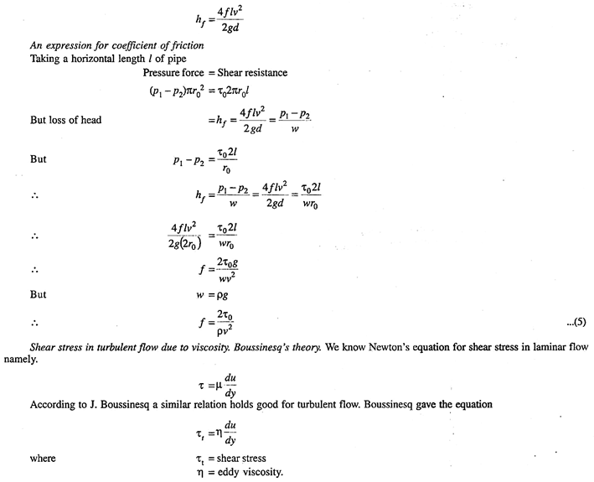

Prandtl Mixing Length Theory:
According to this theory, in turbulent condition the particles of the fluid get transported from one layer of some velocity to another layer of a different velocity. Let l be the distance between the two layers. This distance is called the mixing depth.
Consider two layers I apart having velocities u and u + u’ respectively.
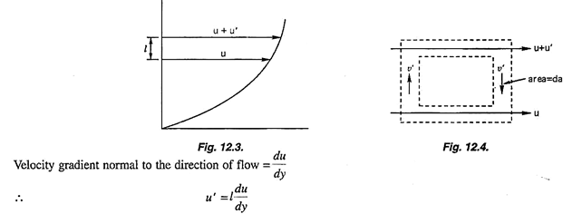
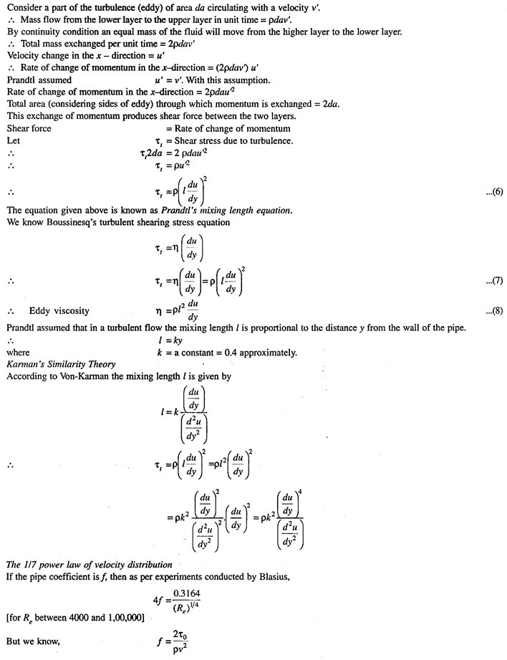
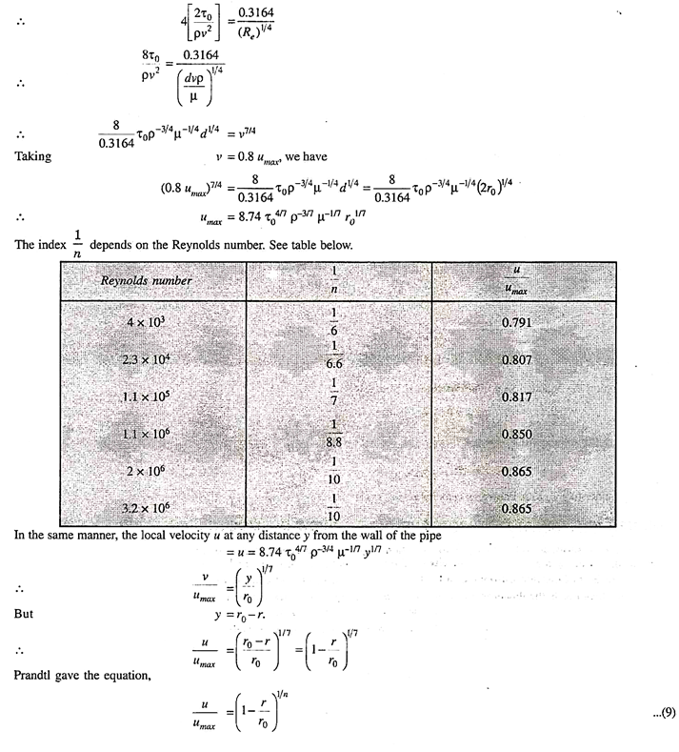

Universal Velocity Distribution:
By Prandtl’s mixing length theory the turbulent shear stress is given by –
Prandtl made an assumption that the mixing depth l is proportional to the distance y from the pipe wall, i.e. I = ky
The constant k is called the Karman constant and has a value equal to 0.4. Prandtl further assumed that the shearing stress remains practically constant.
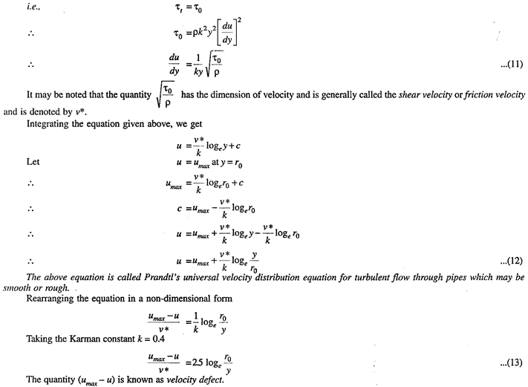

Velocity Distribution for Turbulent Flow in Smooth Pipes:
Prandtl’s universal velocity distribution equation is valid in the central region of the pipe where the turbulent flow is fully developed. But in the regions close to the pipe wall the flow is not fully turbulent, and is more close to laminar flow. There exists a distance 8 from the surface of the wall up to which the velocity varies linearly. See Fig. 12.5.
This thickness is the thickness of the laminar sub-layer and is very small compared with the pipe radius r₀.
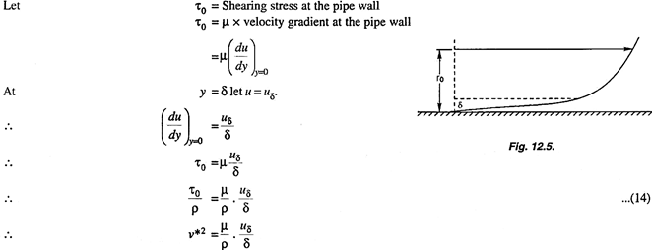
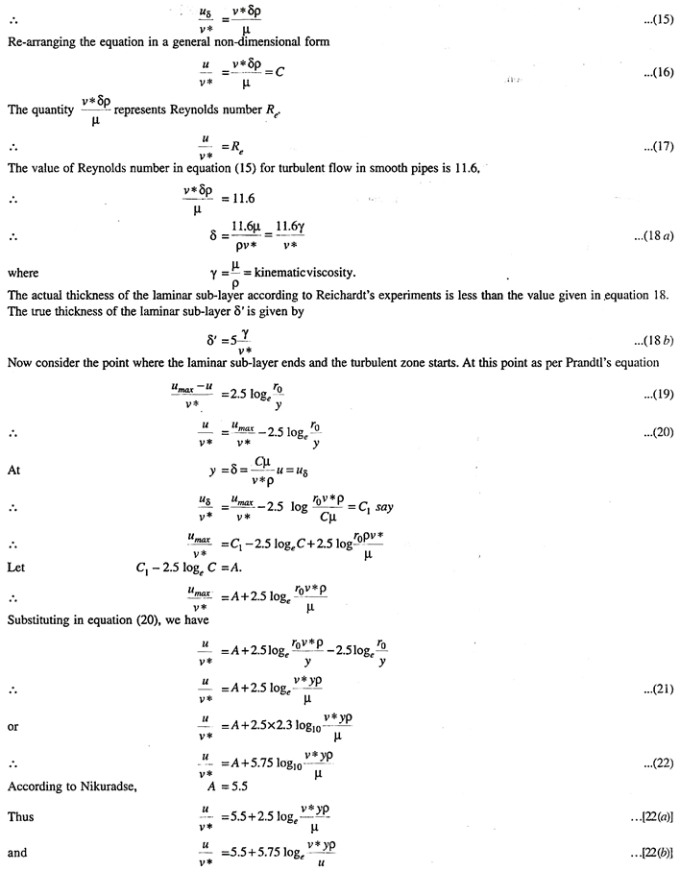

Velocity Distribution for Turbulent Flow in Rough Pipes:
The roughness of the pipe wall is due to the undulation of the surface or uneven projection of the surface. Let ϵ be the average height of protuberance (projection), and r₀ the radius of the pipe. If ϵ > laminar sublayer the pipe is considered as a rough pipe. The distribution of velocity in this case can be derived as follows.
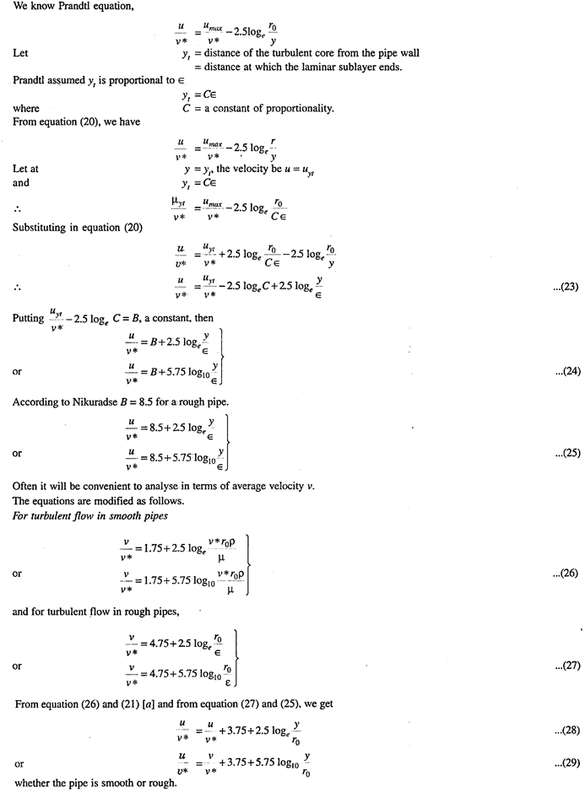

Loss of Head in Pipe Lines:
Losses of head in pipe lines may be secondary losses and major or primary losses. Secondary losses are caused due to significant change in flow pattern. Such losses occur due to contractions, enlargements, bends, valves, fittings etc. Entrance losses occur when the liquid enters a pipe from a large tank. The amount of this loss depends upon the shape of the entrance.
This loss is very small in the case of rounded entrance. Exit losses occur when the liquid leaves the pipe and enters a large tank. Abrupt increase or decrease of pipe size causes sudden enlargement or contraction losses. Secondary losses may be neglected where pipe length exceed 1000 diameters.

Loss of Head due to Pipe Friction or Primary Loss of Head:
Consider a liquid flowing fully through a pipe of diameter d. Consider the part of pipe of length l between sections 1-1 and 2-2. See Fig. 13.1.
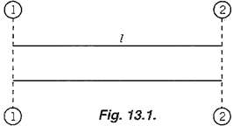
Let v be the velocity of flow through the pipe.
As the quantity of the liquid flows through the pipe, there will be a frictional resistance.
According to Froude,
Frictional resistance = f x contact area x (velocity)²
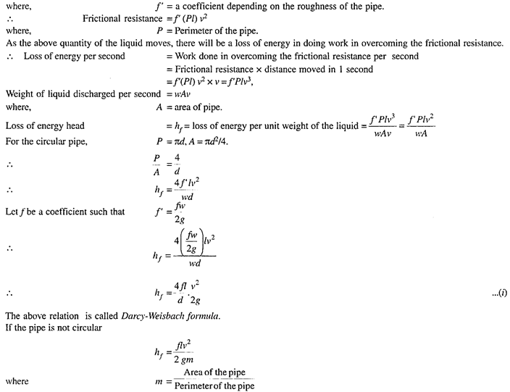
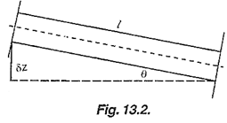
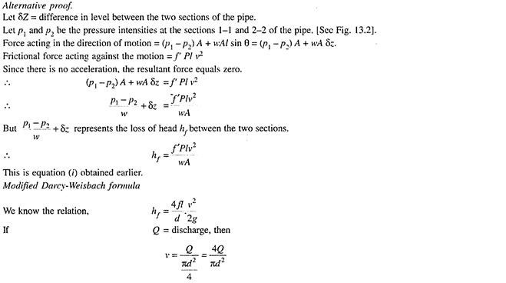
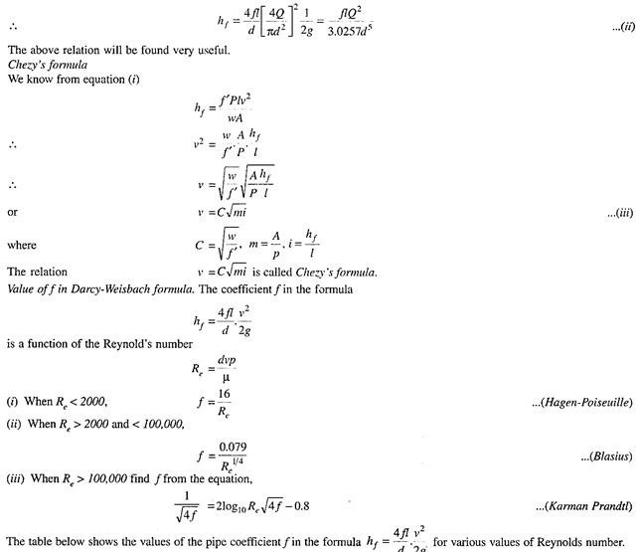
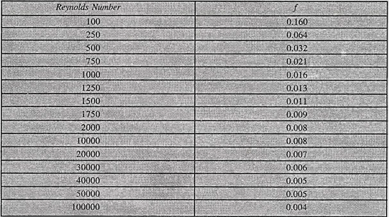

The Hydraulic Gradient:
When a fluid flows through a pipe, it is subjected to a frictional resistance depending on the velocity of the fluid, the area of the wetted surface and on the roughness of the surface. When we consider a long pipe line, the frictional resistance is so large that other resistances may be taken as insignificant. The energy lost in overcoming the frictional resistance, per unit weight of the liquid is the energy head lost in friction and is expressed in metres of the liquid.
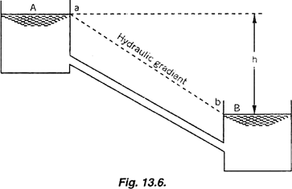
Fig. 13.6. shows a long pipe of length/connecting two reservoirs A and B. Let h be the difference of the liquid levels of the two reservoirs. Let p be the pressure intensity of the liquid at any section of the pipe. The corresponding pressure head at the section is p/w.
Suppose the pressure head of the liquid at all sections of the pipe be plotted as vertical ordinates, taking the centre line of the pipe as a base line, we get a sloping line ab falling uniformly from A to B, since there is a uniform loss of head due to friction as the liquid flows along the pipe.
This line is called the hydraulic gradient. The hydraulic gradient line connects the points to which the liquid would rise in the piezometers introduced at the corresponding points in the pipe. The slope of the hydraulic gradient is equal to the total loss of head divided by the total length of the pipe.
Slope of the hydraulic gradient line = i = h/l
When the pipe has a uniform diameter throughout its length and if the entire available head is lost in friction the hydraulic gradient line will be the line joining the surfaces of liquids in the two reservoirs. This line has been shown as ab in Fig. 13.7. If a number of vertical piezometer tubes be fitted to the pipe at various points, the free liquid surfaces in the piezometer tubes will be at the levels of the hydraulic gradient line. See Fig. 13.7.
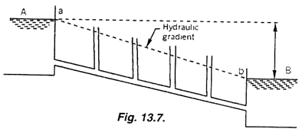
It should be realized that the loss of energy head is due to frictional resistance against the motion of the liquid. If two reservoirs are connected by a pipe line and if the levels of the liquid in the reservoirs are the same then there would be no flow through the pipe line and the liquid levels in the various piezometers fitted to the pipe will be at the same level equal to the level of the liquid in the two reservoirs.
When there is a difference of liquid levels in the two reservoirs, there will be a flow of the liquid in the pipe line and there will be a frictional resistance and accordingly there will be a slope of the hydraulic gradient line.
Now let us consider a pipe line connecting two reservoirs A and B separated by a ridge. See Fig. 13.8. Let the pipe of uniform diameter be laid over the ridge. Ignoring secondary losses, the loss of energy head which is mainly due to friction is again equal to the difference of levels of the liquids in the two reservoirs.
This loss of energy head will take place uniformly along the length of the pipe. The hydraulic gradient line is again a straight line making the assumption that the length of the pipe is nearly equal to the length of straight line ab joining the two liquid surfaces.
The pressure head at any section of the pipe is represented by the vertical distance between the hydraulic gradient line and the centre line of the pipe. Where the centre line of the pipe is below the hydraulic gradient line, the pressure head is greater than the atmospheric pressure head.
Where the centre line of the pipe is above the hydraulic gradient line, the pressure head is less than the atmospheric pressure head. In Fig. 13.8, c and d are the points of intersection of the hydraulic gradient line and the centre line of the pipe.
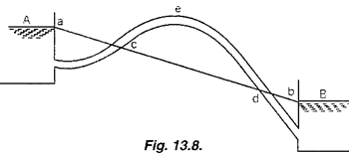
At these points c or d the pressure head is atmospheric but between c and d the pressure head is less than the atmospheric pressure head. Let e be the highest point of the pipe line. The pressure head at e is the lowest. For continuity of flow the pressure head at e must not fall below the separation pressure head. If the liquid flowing is water, the separation pressure head is 2.5 metres (absolute).
If the absolute pressure head at e falls below the separation pressure head the liquid will commence to vapourise producing gas bubbles and the flow will cease. Hence the pipe lines must be so planned that nowhere the absolute pressure head in the pipe line falls below the separation pressure head.
If a part of a pipe line is above the hydraulic gradient line, the pipe is called a syphon. It is quite possible that a pipe line may remain below the upper reservoir level, but still it will be called a syphon if somewhere it is above the hydraulic gradient line.
Let us now consider a pipe of small length connecting two reservoirs A and B.
Let the water flow from the reservoir A to the reservoir B. along the pipe. We know that at any section of the pipe the total energy head = datum head + pressure head + kinetic head.
With reference to the datum line and starting from the water levels in the reservoir A let us mark off the losses of energy head in the pipe line due to all causes. The line obtained in this way is called the total energy line. This line is shown dotted in Fig. 13.9. The height of the total energy line above the datum line for any section of the pipe represents the total energy head at that section. The pipe line consists of the components ab, bc and cd of different lengths and sizes.
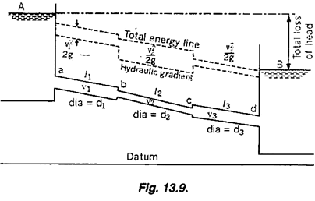
Let v₁, v₂, and v₃ be velocities in the pipes ab, bc and cd. Let l₁, l₂ and l₃ be lengths of these components of the pipe.

The following losses of head will occur:
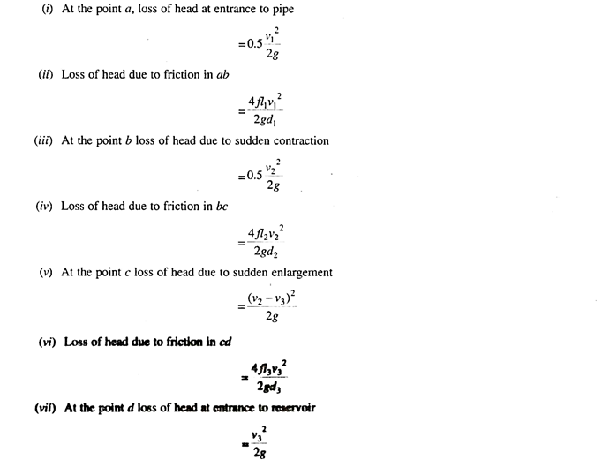
The sum of all these losses of head should be equal to the difference of water levels in the reservoirs A and B.
In Fig. 13.9, the total energy line is shown as the dotted line. Now it is easy to obtain the hydraulic gradient line.
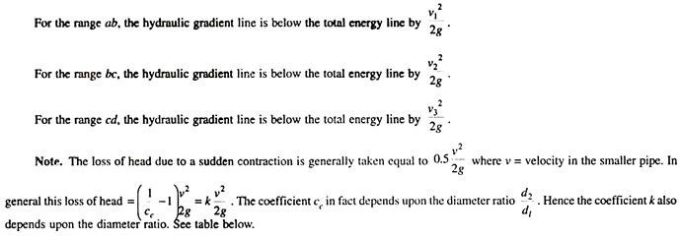
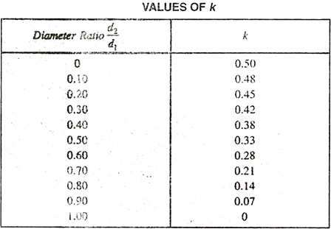
Pipe discharging from a reservoir to the atmosphere-
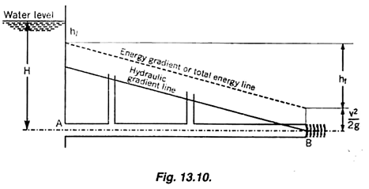
Fig. 13.10 shows a pipe of uniform diameter d connected to a reservoir and discharging to the atmosphere. As the water enters the pipe, a loss of head h_{l} occurs. Thus at the entrance A there is a drop in the energy gradient line by h_{l}. The hydraulic gradient line is below the energy gradient line. The vertical intercept between these two lines is equal to V²/2g.
Applying Bernoulli’s equation to the free water surface in the reservoir and the outlet of the pipe,
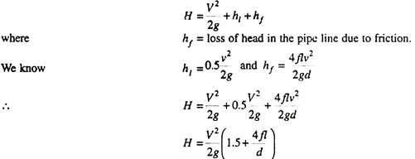

Syphon:
Sometimes it may become necessary to provide a pipe line over an obstacle like a ridge or small hill and then to a lower level. Quite a part of the pipe line may be situated not only above the hydraulic gradient line but also above the water level of the supply reservoir. Such a pipe is called a Syphon. The pressure of water in the part of the pipe line above the hydraulic gradient line will be less than the atmospheric pressure. At the highest point of the syphon called the summit, the pressure is minimum.
Applications of Syphons:
Syphons have the following applications:
(i) Transmission of water from one reservoir to another separated by a ridge.
(ii) To empty a tank not provided with any outlet.
(iii) To take out water from a channel not provided with any outlet sluice.
Consider the syphon provided connecting the reservoirs shown in Fig. 13.27. Let A and C refer to the high and low reservoir water levels. The reservoirs are connected by the syphon pipe which is taken over a ridge B.
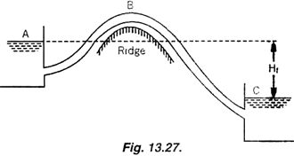
The part of the pipe from the high level reservoir to the summit is called the inlet leg. The part of the pipe from the summit to the low level reservoir is called the outlet leg.

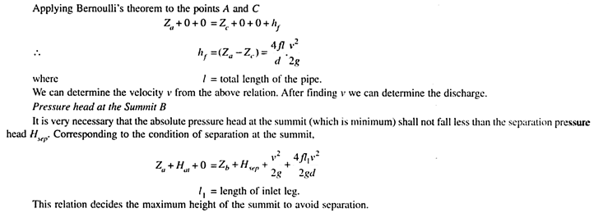

Flow through Pipes in Series and Parallel: Difference Diameters, Equations
:

Pipe in Series:
Pipes are said to be in series if they are connected end to end (in continuation with each other) so that the fluid flows in a continuous line without any branching. The volume rate of flow through the pipes in series is the same throughout.
Suppose a pipe line consists of a number of pipes of different sizes and lengths. See Fig. 13.37.
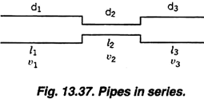
Let d₁, d₂, d₃ be the diameters of the component pipes.
Let l₁, l₂, l₃ be the lengths of these component pipes.
Let v₁, v₂, v₃ be the velocities in these pipes.
Pipes connected in continuation as in this case are said to be connected in series. In this arrangement the rate of discharge Q is the same in all the pipes. Ignoring secondary losses the total loss of head is equal to the sum of the friction losses in the individual pipes.
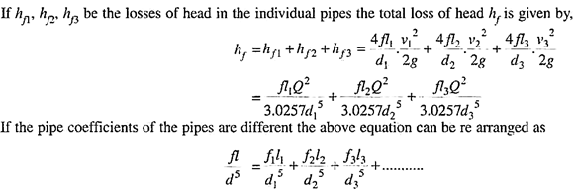
Equivalent Pipe Corresponding to a Given Set of Pipes in Series:
Let d₁, d₂, d₃ be the diameters, and l₁, l₂, l₃ be the lengths of the various pipes in a series connection. Let Q be the discharge. Let h_{f} be the total loss of head.
Let d be the diameter of an equivalent pipe of length l to replace the compound pipe to pass the same discharge at the same loss of head.
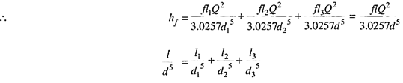
The above relation is called Dupuit’s equation.

Equivalent Length of a Pipe with Intermediate Fittings:
Suppose a pipe of length I is provided with an intermediate fitting due to which the loss of head = k(v²/2g). Let I_{e} be the length of pipe, the friction loss due to which is equal to k(v²/2g).
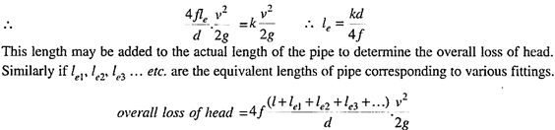

Pipes Connected in Parallel:
Pipes are said to be in parallel when they are so connected that the flow from a pipe branches or divides into two or more separate pipes and then reunite into a single pipe.
Suppose a main pipe branched at section 1-1 into two pipes of lengths l₁ and l₂ and diameters d₁ and d₂ and unite again at a section 2-2 to form a single pipe.
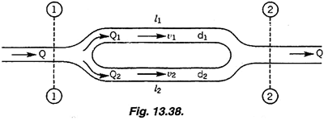
Then the two branch pipes are said to be connected in parallel.

Assignment No. - 2

Q1 Derive an expression for the head loss due to sudden enlargement in pipe flow and there from deduce the head loss due to sudden contraction.
Q2 Two reservoirs whose surface levels differ by 30 meters are connected by a pipe 600mm diameter and 3000m long. The pipe line crosses a ridge whose summit is 9m above the level of and 300m distant from the higher reservoir. Find the minimum depth below the ridge at which the pipe must be laid if the absolute pressure head in the pipe is not to fall below 2.5m of water, and calculate the discharge. Take atmospheric pressure head = 10.3m of water and f= 0.0075
Q3 The difference of water level of two reservoirs is 8m. They are connected by a 40m long pipe. For the first 25m length, the diameter of the pipe is 120mm and for the remaining length the diameter is 200mm, the change in diameter being sudden. Find the discharge into the lower reservoir. Take f=0.008
Q4 Two reservoirs whose water levels differ by 75m are connected by a 500mm diameter, 10000m long pipe. In order to increase the discharge to the lower reservoir by 40% another pipe of same diameter is provided in parallel for a certain length with the latter part of the main pipe . Find the length of the additional pipe. Take f = 0.005. Ignore minor losses.
Q5 The cross sectional area of a pipe of length 100m has parabolic variation with area at the two ends equal to 1m² and area at mid-length equal to 0.9m², Calculate the equivalent area of the pipe.
Q 6 Water from a main canal is siphoned to a branch canal over an embankment by means of wrought iron pipes of 9 cm diameter. The length of pipe upto summit is 25m and the total length is 65 m. Water surface elevation in the branch canal is 10 m below the main canal. What is the maximum permissible height of the summit above the water level in the main canal so that the water pressure of summit may not fall below 0.2 bar absolute, the barometer reading being 10 m of water. Take the value of coefficient of friction as 0.0075 and consider all the losses that are occurring.
Q7 The rate of flow through a horizontal pipe is 25 m³/s. The diameter of pipe which is 200 mm is suddenly enlarged to 400 mm. The pressure intensity in the smaller pipe is 11.772 N/cm². Determine the loss of head due to sudden enlargement and pressure intensity in the larger pipe. Also determine the power lost due to enlargement.
Q8 Two pipes connected to a reservoir discharge water freely to the atmosphere at their outlet ends. The first pipe which is 150mm in diameter and 300m in length has its outlet end at a depth of 3.8m below the water level in the reservoir. The second pipe is 200mm in diameter and 600m long. If the combined discharge is 50 liters per second, find how much below the reservoir water level, the outlet end of the second pipe is situated. Take f=0.0045.

Q9 Two reservoirs A and B are connected by 300mm diameter 1000m long pipe. The difference of water levels in the tanks is 15m. The pipe passes over a hill at C. Find the length of the pipe from the reservoir A to C so that the absolute pressure head at C is 2.5m (abs). The height of C above the water surface of the upper reservoir A is 5m. Find also the discharge. Take f=0.0075. Neglect all losses other than friction .
Q10 Explain the total energy line (energy gradient line) and the hydraulic gradient line for fluid flow through a piping system.

